THE COFFEE CIRCLE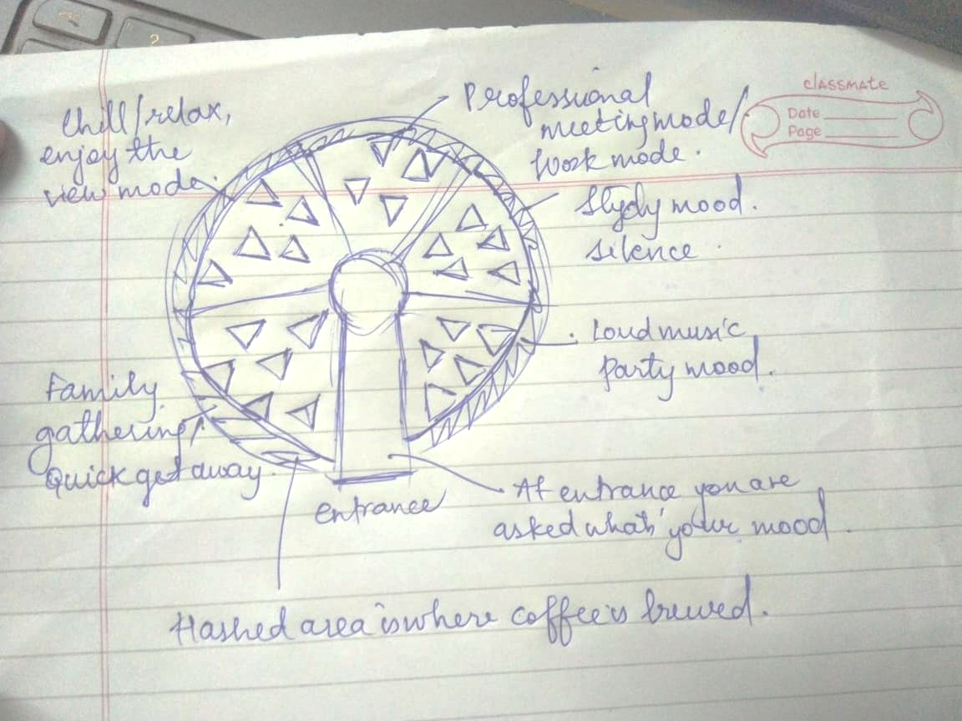

Circular shaped coffee house

-Has 5 divisions depending on purpose: Party mood, study mood, professional meeting mood, relax mood, family gathering mood.

-Table are in form of triangles since if there are multiple people traingles can always combine to give a bigger shape

-In each section music and the entire atmosphere is according to the purpose and predecided mood

-At the back of each the coffee brewing counters are located, where a person and walk and order